28.16: a) B = 0 since the fields are in opposite directions.
b) 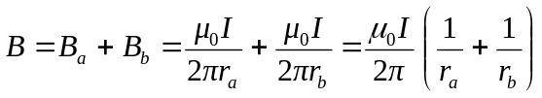
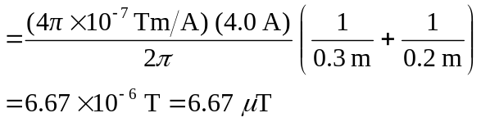
c)
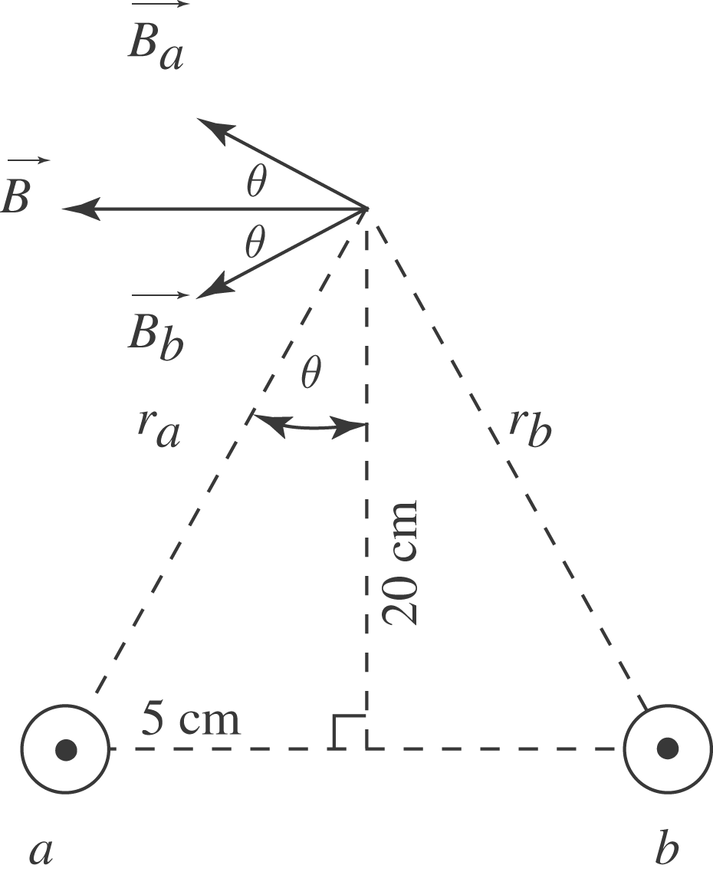 Note that 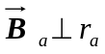 and 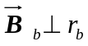
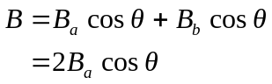

tan 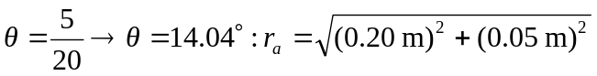
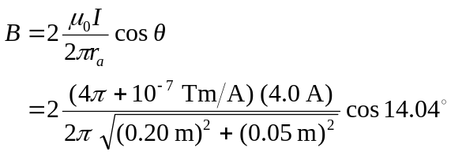

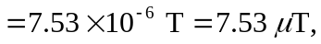 to the left.

